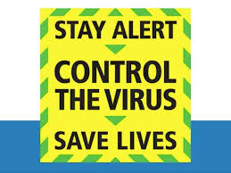
Covid 19 Risk Assessment Plan

Version 1.0.
Last Reviewed on: 15th May 2020.

Introduction

Secure Care UK provides Mental Health transport and other care services to the NHS and private health providers. Our specialism is working with more acute patients. The Board and Leadership Team have reviewed the Government advice which has shown below and undertaken risk assessments which have led to changes to working practices in three principle areas:
- Our Hastings(St Leonards) Head Office Building has been reviewed to implement Social Distancing
- We have provided guidance to our teams working with Mental Health Patients
- We have provided guidance on completing training, some of which is “Hands on” at this time
- We have small deployment bases in Havant (Hampshire), Leeds, Birmingham and Leeds. These locations have also been reviewed to implement the government recommendations.

Important note for context: The care we provide as an organisation is focused on supporting patients with higher levels of need. It is often necessary for our trained teams to undertake “Hands on” interventions such as restraints to keep patients safe from harming themselves and others. Clearly such activity cannot be undertaken in a socially distanced way. Our company ethos and values are designed to utilise de-escalation techniques as far as possible to avoid contact and to try and preserve the dignity of the patient it is however necessary at times to restrain patients and therefore close proximity working is inevitable. We have reviewed NHS guidelines and are following NHS protocols in this area.

Government Guidelines

The information below has been copied from the Gov.co.uk website on Wednesday 13th May.

5 key points
This sets out practical steps for businesses focused on 5 key points, which should be implemented as soon as it is practical:

1. Work from home, if you can
All reasonable steps should be taken by employers to help people work from home. But for those who cannot work from home and whose workplace has not been told to close, our message is clear: you should go to work. Staff should speak to their employer about when their workplace will open.

2. Carry out a COVID-19 risk assessment, in consultation with workers or trade unions
This guidance operates within current health and safety employment and equalities legislation and employers will need to carry out COVID-19 risk assessments in consultation with their workers or trade unions, to establish what guidelines to put in place. If possible, employers should publish the results of their risk assessments on their website and we expect all businesses with over 50 employees to do so.

3. Maintain 2 metres social distancing, wherever possible
Employers should re-design workspaces to maintain 2 metre distances between people by staggering start times, creating one way walk-throughs, opening more entrances and exits, or changing seating layouts in break rooms.

4. Where people cannot be 2 metres apart, manage transmission risk
Employers should look into putting barriers in shared spaces, creating workplace shift patterns or fixed teams minimising the number of people in contact with one another, or ensuring colleagues are facing away from each other.

5. Reinforcing cleaning processes
Workplaces should be cleaned more frequently, paying close attention to high-contact objects like door handles and keyboards. Employers should provide handwashing facilities or hand sanitisers at entry and exit points.
A downloadable notice is included in the documents, which employers should display in their workplaces to show their employees, customers and other visitors to their workplace, that they have followed this guidance.
As a result of reviewing this guidance we have completed our risk assessments and documented our approach in the tables below. During May we will be asking our nominated Health and Safety Representatives to attend our sites and review the measures taken with the Regional Manager with site responsibility in order to refine and improve our actions. Updated Versions of this document may be posted during May as these meetings proceed and any improvements are made.

Secure Care UK, Covid 19 Risk Assessments.

Covid 19 Risk Assessment

Hastings Office
Location | Risks | Steps Taken
General Building | The building is a converted light industrial unit with a range of small and larger rooms. The environment is not modern but equally the amount of people who work in the space (Circa 11 EFT at any time) is low with occasional training and meetings increasing this number. | - Higher risk/shielded employees equipped with company telephony to work from home but linked to our call recorded network. GDPR guidelines in place with signed confirmation of understanding  - General “Decon 7” fogging completed by Eco clense Ltd on a monthly basis with all staff out of the building this is an NHS decontamination standard cleanse.  - Cleaning schedule put in place with focus on Door handles, toilets  - Cleaning wipes readily available with posters encouraging use  - Team guidance sheets provided explaining the measures and their part in the requirements and keeping one another safe.
Entrance | Covid Symptomatic people entering the building.  People stopping in groups in enclosed spaces | - Reminder not to enter if displaying symptoms placed outward facing including copy of NHS website description of symptoms  - Hand sanitiser at entrance  - Due to low number of people working from the site and size of company temperature checks not economically viable, assessed and rejected.  - Designated as a “No stopping” transit area
Crew Room | Too many people in room and or lack of cleaning | - Cleaning regime with focus on door handles and desk area  - Zones to 2 person room  - Signage in place  - General messages in communication
Sink area | Too many people in room and or lack of cleaning | - Washing machine decommissioned as towels and reusable items not appropriate at this time.  - Larger space and limited use room but limited to 3 people due to also being transit area. Signage in place
Control Room | Main work environment with desks where people are based for long shifts and phones/other higher risk equipment.  Crews come in and out of the area to collect equipment bags  Seating for breaks | - Desk space redesigned to enable no hot desking and designated desks per person  - Higher risk team and some others working from Home with our IT and interlinked telephony  - Area zoned and limited to 8 people  - Rest area seating reduced seating removed and spaced  - Physical white boards replaced by excel version  - All messaging deployed  - Cleaning regime in place  - Due higher risk nature of the room specific pictorial guides in use
HR Office 1 | Too many people in room and or lack of cleaning. PC and telephone equipment | - One team member shielding so not attending  - Screen added between desks  - Hot desking stopped, designated equipment  - Cleaning regime with focus on door handles and desk area  - Zones to 2 person room  - Signage in place  - General messages in communication
HR Office 2 | Too many people in room and or lack of cleaning | - Hot desking stopped, designated equipment  - Cleaning regime with focus on door handles and desk area  - Zones to 2 person room  - Signage in place  - General messages in communication
Kitchen | Too many people in room and or lack of cleaning | - Limited to one person only  - Cleaning regime in place
Waiting Area | Too many people in room and or lack of cleaning | - Limited to one person only  - Cleaning regime in place  - One chair decommissioned
Upper Corridor | Transit Area | - Signage in place
Finance Manager Office | Too many people in room and or lack of cleaning | - Limited to one person only (Not Hot desk)  - Cleaning regime in place
Finance Room | Too many people in room and or lack of cleaning | - Limited to two people only (Not Hot desk)  - Cleaning regime in place
Storage Room | Too many people in room and or lack of cleaning | - Adjusted to allow meeting area for 2 people with zones to take pressure off other areas  - Cleaning regime in place
Main Meeting Room | Too many people in room and or lack of cleaning and used for larger groups/ longer discussions.  Main table can be used by lots of people | - Area zoned and limited to 6 people  - Rest area seating reduced seating removed and spaced  - Physical white boards replaced by excel version  - All messaging deployed  - Cleaning regime in place  - Due higher risk nature of the room specific pictorial guides in use  - If used for training, Training Risk assessment applies
First Floor Stair Well | Transit area | - Signage in place

 | Risks | Steps Taken
Vehicles | Higher risk activity due to potential hands one nature of work and the need to be within 2m regularly to ensure patient and crew safety | - PPE guidance in place and reinforced  - Guidance in each vehicle as to where to sit (linked to crew size) when patient is not in the vehicle  - Heavy communication to crews on testing availability and the need to self isolate if required

 | Risks | Steps Taken
Suites and working with patients | Higher risk activity due to potential hands one nature of work and the need to be within 2m regularly to ensure patient and public safety | - PPE guidance in place and reinforced in communications and in line with NHS Ambulance guidance (see page 11)  - Heavy communication to crews on testing availability and the need to self isolate if required

 | Risks | Steps Taken
Training | In order to properly prepare people for the requirements of their role physical training is required | - Hand sanitiser and regular hand washing breaks  - Large room used and seats socially distanced  - PVMA training with instructor in full suit all trainees in masks with gloves

Base Locations | Risks | Steps Taken
Leeds | Small room environments. | - 2 Rooms each zoned and limited to 3 people  - General Signage in place including warning not to enter on outside  - Cleaning regime in place
Lincoln | Small room environment | Room limited to 3 people  - General Signage in place including warning not to enter on outside  - Cleaning regime in place
Havant | Small room environment | - Room limited to 4 people  - General Signage in place including warning not to enter on outside  - Cleaning regime in place
Birmingham | Very small room environment | - Room limited to 2 people  - General Signage in place including warning not to enter on outside  - Cleaning regime in place  - Crews required to contact office and it team are in the room they are to wait near the vehicle for equipment to be brought to them

Signage Used
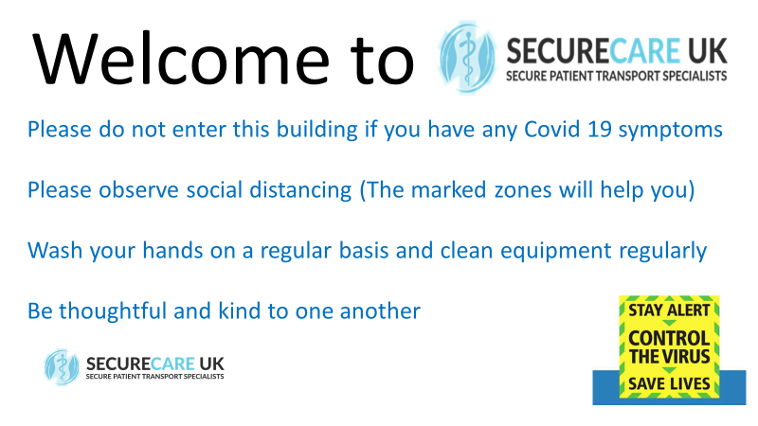 | 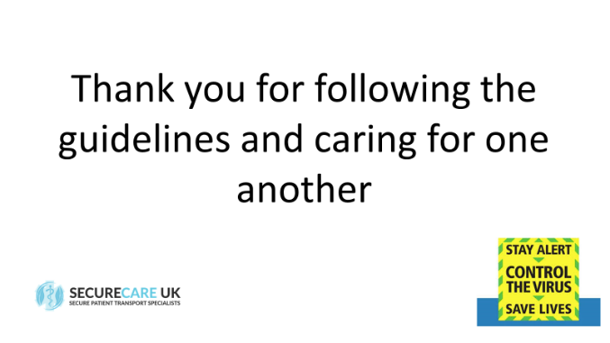 | 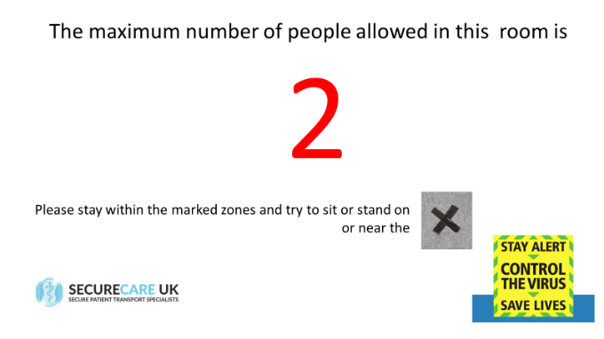
Front door sign | Exit sign | Room use clarity template (Number changed)
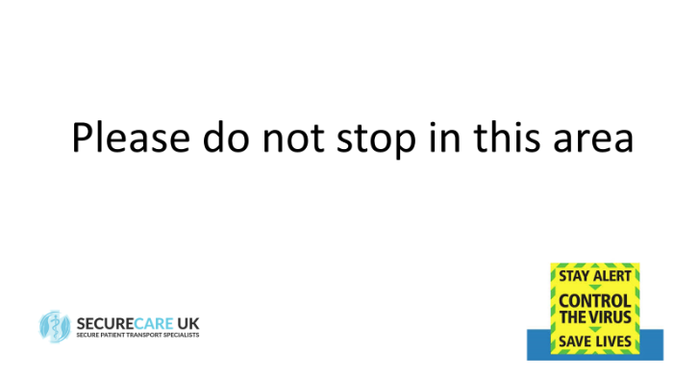 | 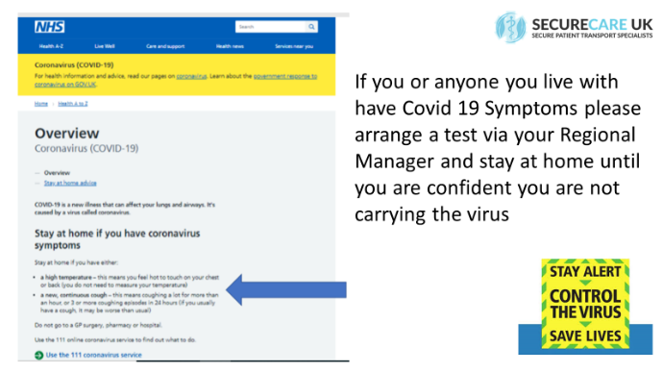 | 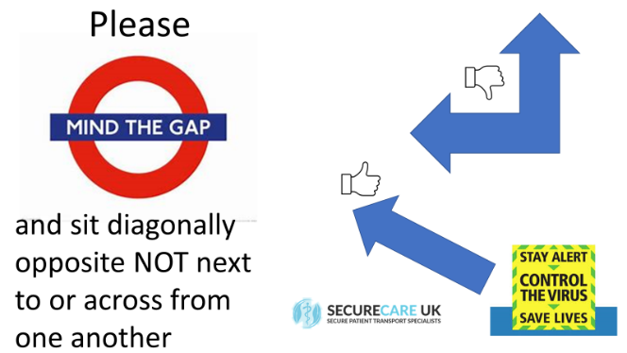
Transit areas | Testing reminder | Control Room safe distancing plan
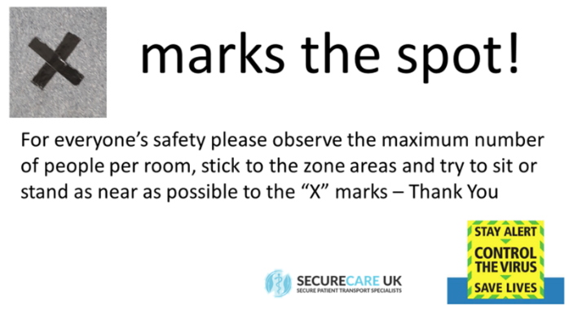 | 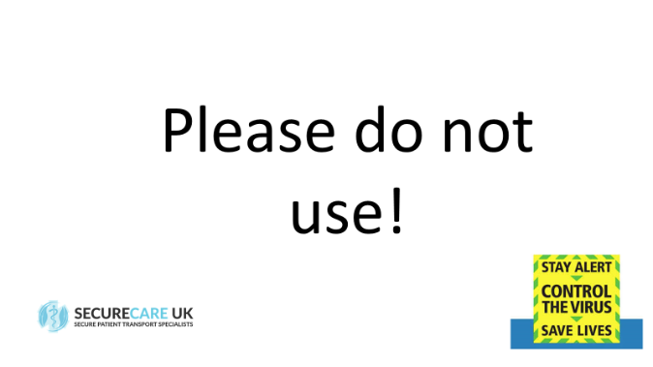 | 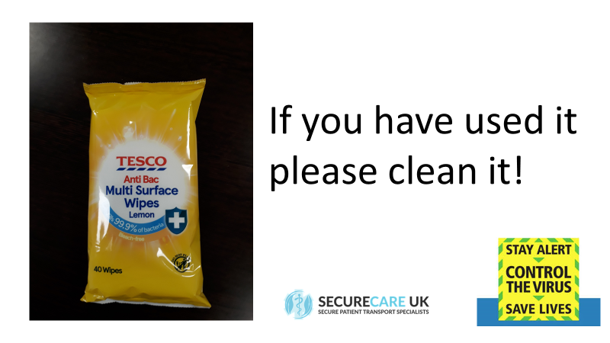
Communication of Zones | Equipment removed from use e.g. seats | Cleaning reminder linked to plentiful equipment
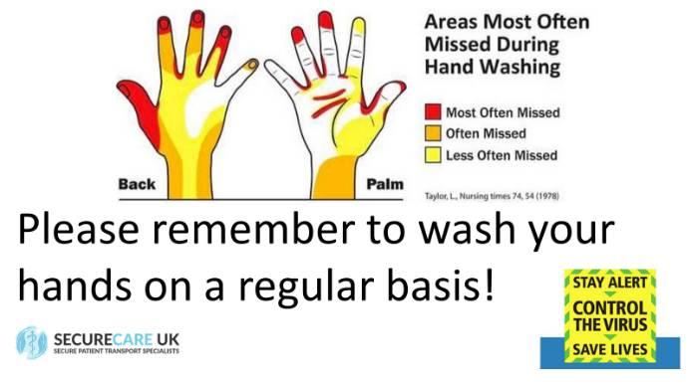 | 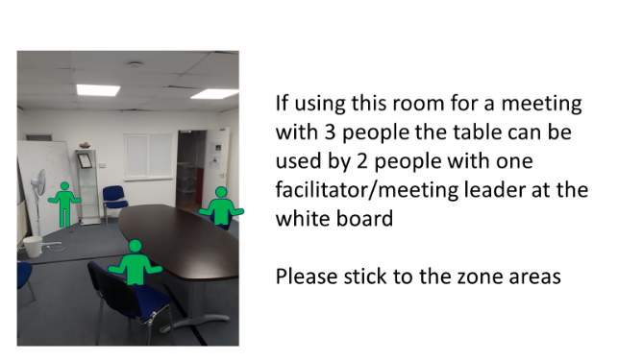
Personal hygiene reminder | Example of individual room explanation.

